HSE Smart Scheduler

Description:

Our application is a smart timetable for HSE students combining RUZ database, simple user planner, geolocation API and reminder-notification for an effective time management. At the entrance of any HSE building student will be reminded with the nearest lection/seminar time and an auditory.

Central repository address: <https://github.com/MarinaKravchenko/smartRUZ.git>

Team members:

Somov Alexander 144 responsible for Application logic

Ermolaev Maxim 144 responsible for BD + tests

Kravchenko Marina 145 responsible for API + GUI

Application classes:

|  |  |
| --- | --- |
| Class name | Description |
| Main Activity | Contains main interaction between interface and data |
| Api Interaction | Receives and parses json information about schedule |
| Personal Data | Saves user personal information (name, group, …) |
| Phone Location | Works with geo services to provide actual information about user’s phone location |
| Schedule Activity | Displays scroll list with all activities on a chosen day |
| Settings Activity | Allows to change personal data to update schedule |
| Calendar Activity | Switches window to a calendar window |
| Edit Activity | Allows to add user event to the schedule |

Program interface:

Application icon is shown in a list of apps on your Android  
  
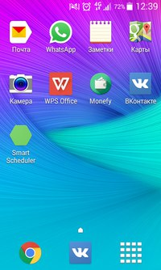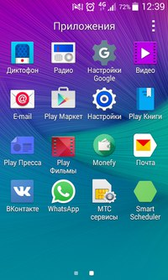

App starts with filling in personal data – name and group  
  
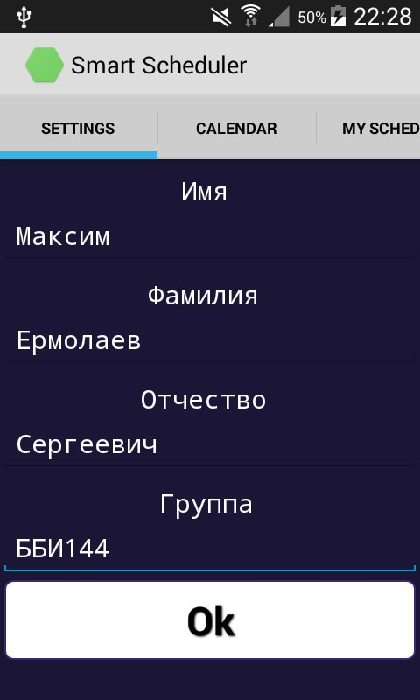

Tabbing on calendar you will be able to choose day and then My schedule window will be opened

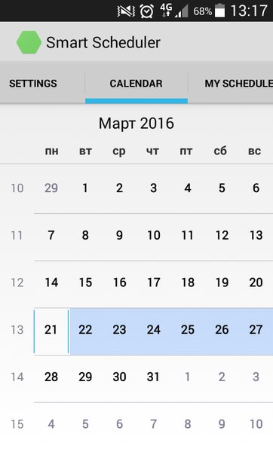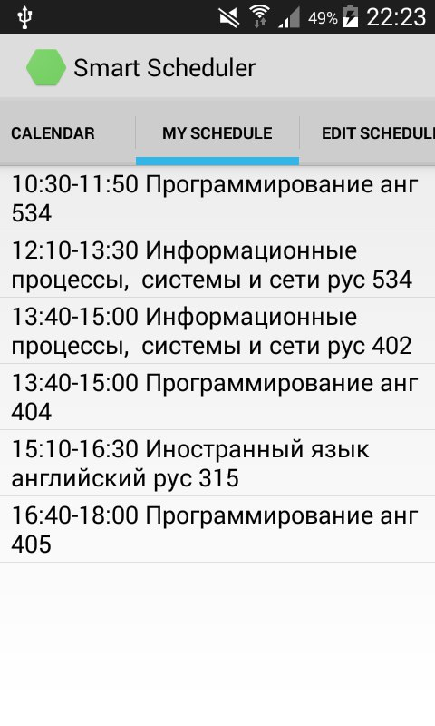

You also can add your own activity

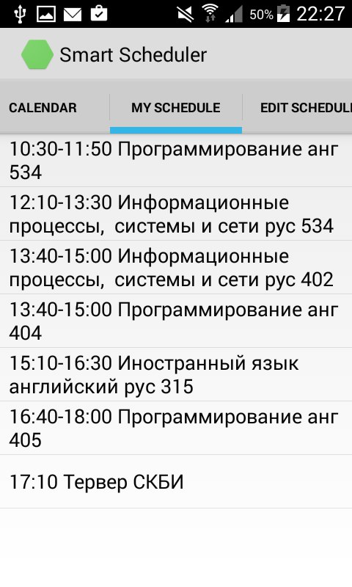

Tabbing on single item you can see details or delete it

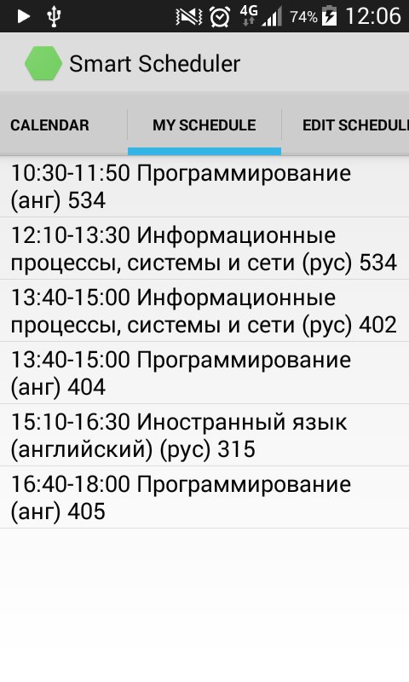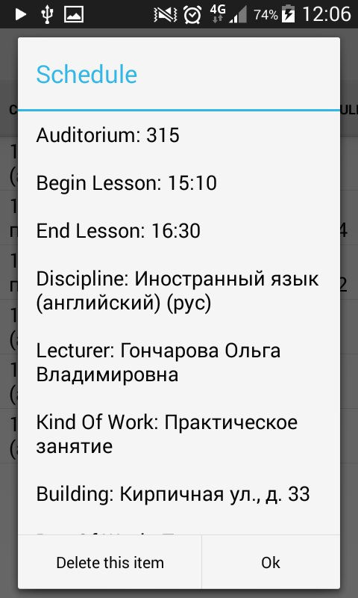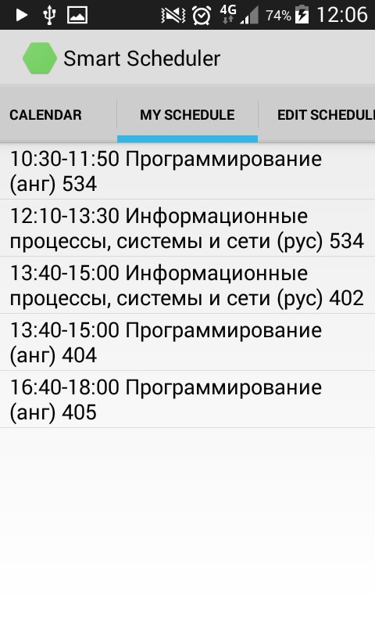

Once you entered building, pop-up notification appears, informing about time and auditorium

